

INTEGRATION

Engineering capstone project-EECE8040

July 24, 2019

VibCHECK

Nivedita Rajendran, Lisler Thomson Pulikkottil, Shadaab Saiyed

Table of Contents

*Table of Figures* 2

*Table of Tables* 3

**1.Introduction** 4

**2.Background Information** 4

**3. Testing** 8

**4. Summary** 13

**5. Reference** 14

***Appendix A*** 15

***Appendix B*** 18

***Appendix C*** 20

# *Table of Figures*

Figure 1 Elevator 1 Module Prototype 7

Figure 2 Elevator 2 Module Prototype 7

Figure 4 Readings from Pump 8

Figure 5 Reading from Elevator 9

Figure 6 Graph obtained when sensor was kept inside the Elevator Cabin 10

Figure 7 Graph obtained when sensor was kept on the Hydraulic Pump 11

Figure 8 Screenshot of Text File saved 12

# *Table of Tables*

Table 1 Arduino-ADXL345 Connections 4

Table 2 Arduino-RFM9x Connections 5

Table 3 Raspberrypi-RFM9x Connections 5

Table 4 Raspberrypi-MPU6050 Connections 6

# **1.Introduction**

The portion of the project which was completed in the previous weeks were to research on the Lo-Ra peer to peer connection with the modules RFM9X (3), and successfully we had completed the coding part to analyze how the communication was taking place between the modules. We were also testing the range of Lo-Ra, how it behaved with obstacles and in different scenarios. We found that LoRa worked absolutely well in all our tests. Hence, we finally decided to go with Lo-Ra peer to peer instead of going Lo-Ra WAN which is much complicated than this one. So, our next step was to do the integration of Arduino-Uno with the RFM9X board hooked up with the 3 Axis accelerometer ADXL345 which acted as the vibration sensor in our project.

# **2.Background Information**

We were researching on the ways to hook them up all together on the bread boards. We figure out that Lo-Ra module uses the SPI communication and accelerometer uses the I2C communication. For the accelerometer to Arduino-Uno connection, the pins were connected in the way given below on the table.

Table 1 Arduino-ADXL345 Connections

|  |  |
| --- | --- |
| **Arduino pins** | **ADXL345 pins** |
| GND | GND |
| 3V3 | VCC |
| 3V3 | CS |
| GND | SDO |
| A4 | SDA |
| A5 | SCL |

For the RFM9x Lo-Ra module to Arduino-Uno connection, the pins were connected in the way given below on the table.

Table 2 Arduino-RFM9x Connections

|  |  |
| --- | --- |
| **Arduino pins** | **RFM9X pins** |
| 5V | Vin |
| GND | GND |
| D3 | G0 |
| D13 | SCK |
| D12 | MISO |
| D11 | MOSI |
| D4 | CS |
| D2 | RST |

For the Raspberry pi 3 to Lo-Ra module RFM9X connections, pins were connected in the way given below on the table.

Table 3 Raspberrypi-RFM9x Connections

|  |  |
| --- | --- |
| **Raspberry pi 3 pins** | **RFM9X pins** |
| 3V3 | Vin |
| GND | GND |
| #5 | G0 |
| SCLK | SCK |
| MISO | MISO |
| MOSI | MOSI |
| CE1 | CS |
| #25 | RST |

For the Raspberry pi 3 to Accelerometer MPU6050 connections, pins were connected in the way given below on the table.

Table 4 Raspberry pi-MPU6050 Connections

|  |  |
| --- | --- |
| **MPU6050 pins** | **Raspberry pi 3 pins** |
| Vin | 3V3 |
| GND | GND |
| SCL | SCL |
| SDA | SDA |

Raspberry pi is used in this project to make the output values from vibration sensor displayed on the monitor as it was requested by the client that he needs the vibration values to be visually big to see ,easy for a tester to view that and note down the readings. The integration of the raspberry pi is still not yet completly done. We are working on how to get the data packets from Lo-Ra module to the raspberry pi without delays and with greater accuracy.

The images of the hooked up Lo-Ra module, accelerometer and Arduino-Uno is attached here below and it’s the setup which is placed at the elevator walls or inside the elevator cab.

Figure 1 Elevator 1 Module Prototype

Figure 2 Elevator 2 Module Prototype

# **3. Testing**

We had made two of these setups, one for the transmission (elevator wall side) and one for the reception on the hydraulic pump. The Lo-Ra module kept inside the elevator cabin was actually sending the real time data of vibrations which occurred during the start, stop and moving of the elevator. And the vibration sensor was detecting vibrations with great accuracy, sensitivity and live values were being displayed on the screen through graph. We were able to display the graphs using the serial plotter on the Arduino IDE. The graph was scaled by default on the IDE.

I have attached the images of the real time vibration values displayed on the screen when the elevator was operated by the sponsor Mike Johnston at Cambridge Elevating. He was observing the output by viewing the graph with values running on it. The image pasted below was taken when the modules were placed on top of the hydraulic pump where the vibrations are very intense.

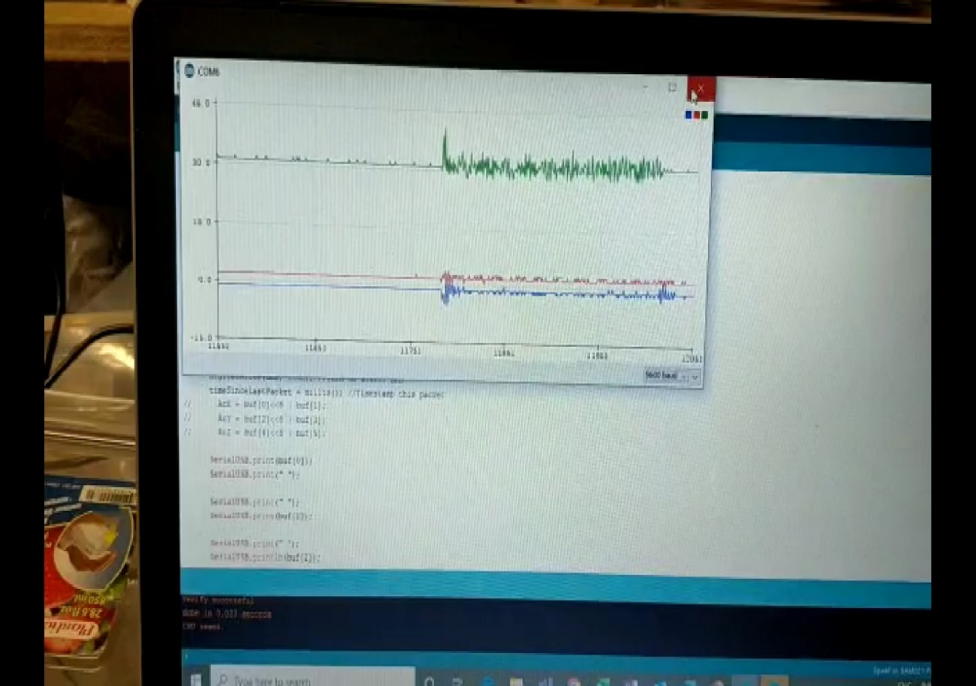

Figure 3 Readings from Pump

The image pasted below was taken when the module was placed inside the elevator cab where the vibrations were comparatively less.

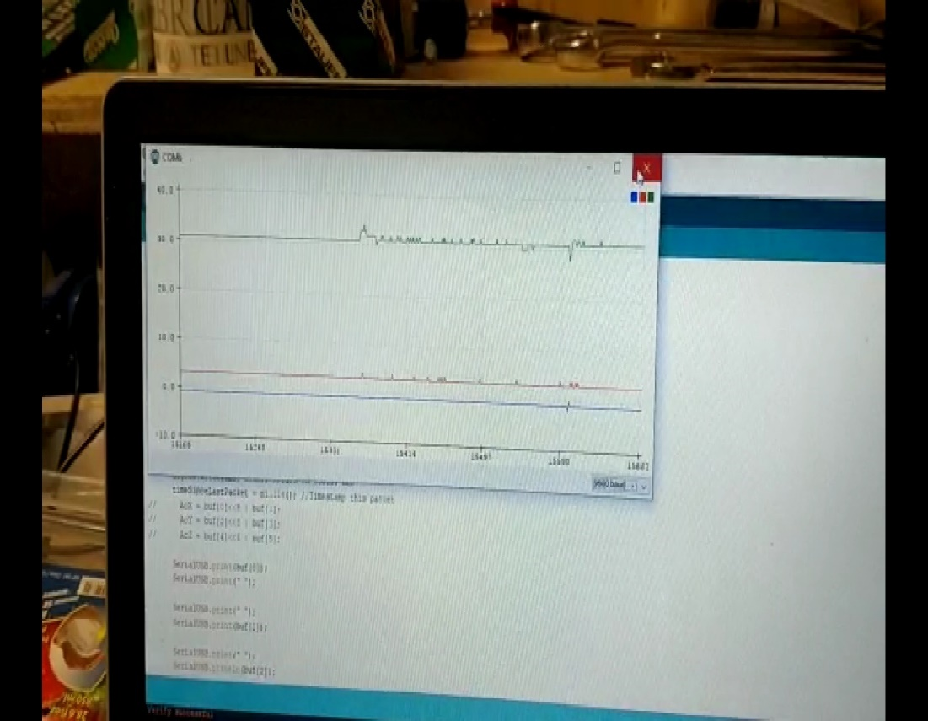

Figure 4 Reading from Elevator

I have also attached some videos of the working and testing of the whole setup on site. It was taken when the elevator was operated.



The following are the updated Tests after we adjusted the sensitivity of the sensor. The test was conducted in two stages - One when the sensor was kept inside the elevator cabin and another one when the sensor is kept on the elevator pump.

The following image shows the sensor reading from inside the cabin

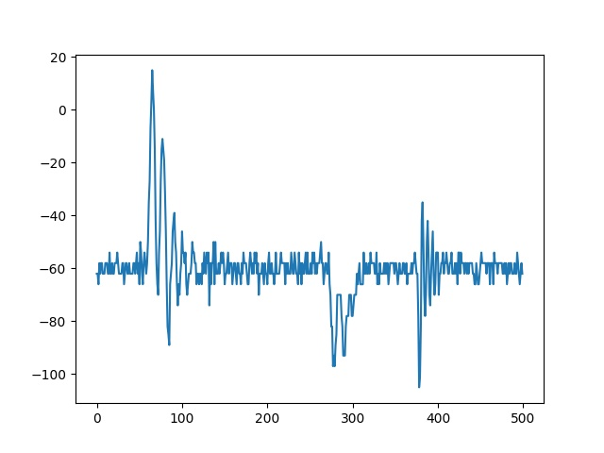

Figure Graph obtained when sensor was kept inside the Elevator Cabin

The following image shows the sensor reading from the Hydraulic pump.

Figure Graph obtained when sensor was kept on the Hydraulic Pump

We were also able to store the sensor reading to a text file so that the testers can access the readings on a later time.

The following image shows a screenshot of the above said text document.

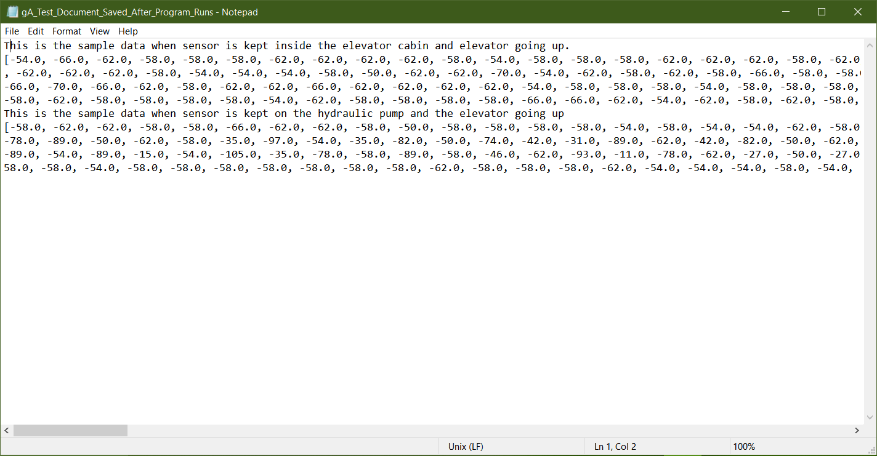

Figure Screenshot of Text File saved

# **4. Summary**

The testing of the existing system has been made and it has been approved by the sponsor under his supervision at Cambridge elevating. Now onwards we will be focusing on making the system much more custom fit and tailored to the sponsor’s needs. As per our sponsor, we are striving to make the display (monitor) much bigger and clearer using the raspberry pi and also trying to add on the option to save the real time sensed values of vibration of elevator on a hard drive storage. We also have planned to make into a product suitable for performing on site rather than the prototype.

# **5. Reference**

<https://conestoga.desire2learn.com/d2l/lms/dropbox/user/folder_submit_files.d2l?db=265395&grpid=279090&isprv=0&bp=0&ou=271571>

# ***Appendix A***

**Transmitter Code**

/\***Lo-Ra Transmitter code**

**Authors**: Lisler Thomson

Nivedita Rajendran

Shadab Saiyed

**Description**: This Code implements the Transmitter end at the Elevator. It takes the Vibration/accelerometer reading from the elevator and transmits over LoRa

**Revision**: C

**Date**: 23.07.2019

*/

#include <SPI.h>

//Radio Head Library:

#include <RH_RF95.h>

// SparkFun ADXL345 Accelerometer Library

#include <SparkFun_ADXL345.h>

ADXL345 adxl = ADXL345(); // USE FOR I2C COMMUNICATION

RH_RF95 rf95(4, 3); // RFM9x Chip Select and Interrupt Pins

int LED = 13; //Status LED is on pin 13

int packetCounter = 0; //Counts the number of packets sent

long timeSinceLastPacket = 0; //Tracks the time stamp of last packet received

float frequency = 921.2; //Broadcast frequency

void setup()

{

pinMode(LED, OUTPUT);

Serial.begin(9600);

Serial.println("RFM Client!");

//Initialize the Radio.

if (rf95.init() == false) {

Serial.println("Radio Init Failed - Freezing");

while (1);

}

else {

//An LED inidicator to let us know radio initialization has completed.

Serial.println("Transmitter up!");

digitalWrite(LED, HIGH);

delay(500);

digitalWrite(LED, LOW);

delay(500);

}

// Set frequency

rf95.setFrequency(frequency);

rf95.setTxPower(14, false); // Sets the transmission frequency

// Power on the ADXL345

adxl.powerOn();

adxl.setRangeSetting(2); // Give the range settings

adxl.setSpiBit(0); // Configure the device to be in 4 wire SPI mode when set to '0' or 3 wire SPI mode when set to 1

adxl.setActivityXYZ(1, 0, 0); // Set to activate movement detection in the axes "adxl.setActivityXYZ(X, Y, Z);" (1 == ON, 0 == OFF)

adxl.setActivityThreshold(75); // 62.5mg per increment // Set activity // Inactivity thresholds (0-255)

adxl.setInactivityXYZ(1, 0, 0); // Set to detect inactivity in all the axes "adxl.setInactivityXYZ(X, Y, Z);" (1 == ON, 0 == OFF)

adxl.setInactivityThreshold(75); // 62.5mg per increment // Set inactivity // Inactivity thresholds (0-255)

adxl.setTimeInactivity(10); // How many seconds of no activity is inactive?

adxl.setTapDetectionOnXYZ(0, 0, 1); // Detect taps in the directions turned ON "adxl.setTapDetectionOnX(X, Y, Z);" (1 == ON, 0 == OFF)

// Set values for what is considered a TAP and what is a DOUBLE TAP (0-255)

adxl.setTapThreshold(50); // 62.5 mg per increment

adxl.setTapDuration(15); // 625 μs per increment

adxl.setDoubleTapLatency(80); // 1.25 ms per increment

adxl.setDoubleTapWindow(200); // 1.25 ms per incremen

// Set values for what is considered FREE FALL (0-255)

adxl.setFreeFallThreshold(7); // (5 - 9) recommended - 62.5mg per increment

adxl.setFreeFallDuration(30); // (20 - 70) recommended - 5ms per increment

// Turn on Interrupts for each mode (1 == ON, 0 == OFF)

adxl.InactivityINT(1);

adxl.ActivityINT(1);

adxl.FreeFallINT(1);

adxl.doubleTapINT(1);

adxl.singleTapINT(1);

}

void loop()

{

int x, y, z;

// Read the accelerometer values and store them in variables declared above x,y,z

adxl.readAccel(&x, &y, &z);

// Stores all three axis values to a single array to transmit

uint8_t toSend[] = {x, y, z};

// Sends Data through LoRa

rf95.send(toSend, sizeof(toSend));

rf95.waitPacketSent(); // Waits till the transmission is completed

}

# ***Appendix B***

**Receiver Code:**

**/* LoRa Receiver Code**

**Authors**: Lisler Thomson

Nivedita Rajendran

Shadab Saiyed

**Description**: This Code implements the Receiver end at the Elevator. It takes the Vibration/accelerometer reading from LoRa and Transmits to Raspberry Pi over Serial USB

**Revision**: C

**Date**: 23.07.2019

*/

#include <SPI.h>

//Radio Head Library:

#include <RH_RF95.h>

RH_RF95 rf95(12, 6);

int LED = 13; //Status LED on pin 13

int packetCounter = 0; //Counts the number of packets sent

long timeSinceLastPacket = 0; //Tracks the time stamp of last packet received

float frequency = 921.2;

void setup()

{

pinMode(LED, OUTPUT);

SerialUSB.begin(9600);

while(!SerialUSB);

//Initialize the Radio.

if (rf95.init() == false){

while (1);

}

else{

// An LED indicator to let us know radio initialization has completed.

digitalWrite(LED, HIGH);

delay(500);

digitalWrite(LED, LOW);

delay(500);

}

rf95.setFrequency(frequency);

}

void loop()

{

if (rf95.available()){

// Should be a message for us now

int8_t buf[RH_RF95_MAX_MESSAGE_LEN];

uint8_t len = sizeof(buf)-1;

if (rf95.recv((uint8_t*)buf, &len)){

digitalWrite(LED, HIGH); //Turn on status LED

timeSinceLastPacket = millis(); //Timestamp this packet

SerialUSB.println(buf[2])

}

}

//Turn off status LED if we haven't received a packet after 1s

if(millis() - timeSinceLastPacket > 1000){

digitalWrite(LED, LOW); //Turn off status LED

timeSinceLastPacket = millis(); //Don't write LED but every 1s

}

}

# ***Appendix C***

**Raspberry Pi Code for Graph and Data Storage**

## VibCheck_Python.py

## Author: Lisler Thomson Pulikkottil;

## Nivedita Rajendran;

## Shadaab Saiyed

## Description: This program takes the readings from sparkfun pro

## RF through serial USB port and displays it on a

## graph. It will also store the readings to a file

import time

import serial

import matplotlib.pyplot as plt

# Initialising the Gragph

fig = plt.figure()

ax = fig.add_subplot(1,1,1)

xs = range(0,500)

ys = []

# Initialising Serial Port

ser = serial.Serial(

port='/dev/ttyACM0',

baudrate = 9600,

parity=serial.PARITY_NONE,

stopbits=serial.STOPBITS_ONE,

bytesize=serial.EIGHTBITS,

timeout=1

)

# Storing Sensor data into an array

for t in range(0,500):

data = ser.readline()

print(float(data))

ys.append(float(data))

# PLotting sensor readings to graph

ax.plot(xs,ys)

# Save plot

plt.savefig('datagraph.jpg')

# Show plot

plt.show()

# Open a file and store the sensor data

f = open("test1.txt","a+")

details = input("Enter Details:")

f.write(details)

f.write("\n")

f.write(str(ys))

f.write("\n")

f.close()